//DEEPIKA SHARMA -124959
ASSIGNMNET-5

5.1 Create Employee table with same structure as EMP table.

CREATE TABLE Employee (EMPNO NUMBER(4) NOT NULL,
ENAME VARCHAR2(10),
JOB VARCHAR2(9),
MGR NUMBER(4),
HIREDATE DATE,
SAL NUMBER(7, 2),
COMM NUMBER(7, 2),
DEPTNO NUMBER(2));

RESULT:-
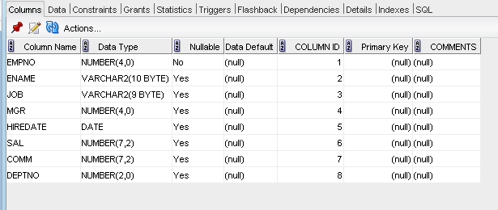

5.2 . Write a query to populate Employee table using EMP table’s empno, ename, sal, deptno columns.
INSERT INTO Employee
SELECT * FROM EMP;
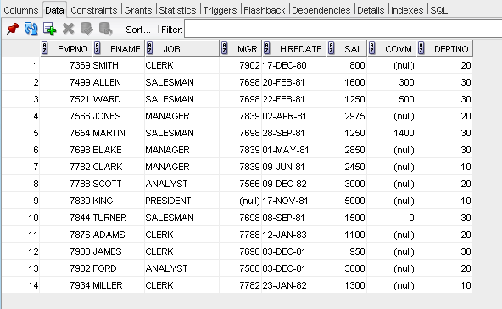

5.3 Write a query to change the job and deptno of employee whose empno is 7698
to the job and deptno of employee having empno 7788.
update Employee
set job = (select JOB from Employee
where empno = 7698),

DEPTNO = (select DEPTNO from Employee
where empno = 7698)
where empno = 7788;
RESULT:-
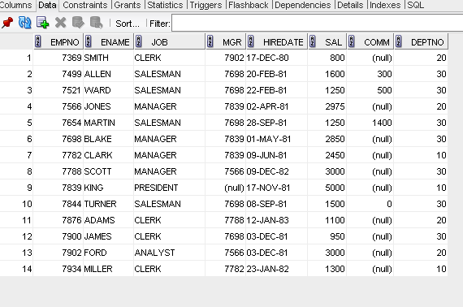

5.4 Delete the details of department whose department name is ‘SALES’.

DELETE FROM EMPLOYEE
WHERE JOB = 'SALESMAN'

5.5 Write a query to change the deptno of employee with empno 7788 to that
of employee having empno 7698.

update Employee
set DEPTNO = (select DEPTNO from Employee
where empno = 7788)
WHERE EMPNO =7698
RESULT:- 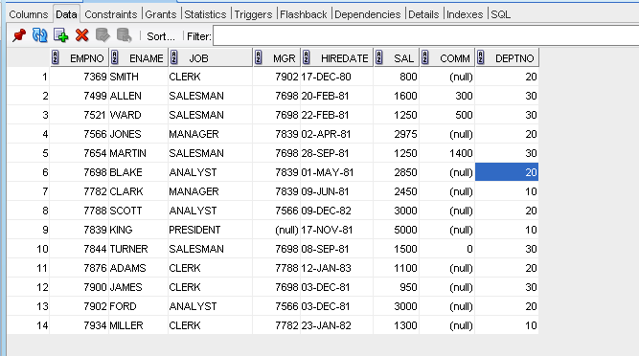

5.6 Insert the following rows to the Employee table through parameter substitution.
• 1000,Allen, Clerk,1001,12-jan-01, 3000, 2,10
• 1001,George, analyst, null, 08 Sep 92, 5000,0, 10
• 1002, Becker, Manager, 1000, 4 Nov 92, 2800,4, 20
• 1003, 'Bill', Clerk, 1002, 4 Nov 92,3000, 0, 20

INSERT INTO EMPLOYEE
VALUES(1000, 'ALLEN', 'CLERK', 1001,
TO_DATE('12-JAN-01', 'DD-MON-YY'), 3000, 2, 10);

INSERT INTO EMPLOYEE
VALUES (1001, 'GEORGE', 'ANALYST', NULL,
TO_DATE('08-SEP-92', 'DD-MON-YY'), 5000, 0, 10);

INSERT INTO EMPLOYEE
VALUES (1002, 'becker', 'MANAGER', 1000,
TO_DATE('04-NOV-92', 'DD-MON-YY'), 2800, 4, 20);

INSERT INTO EMPLOYEE
VALUES (1003, 'BILL', 'CLERK', 1000,
TO_DATE('04-NOV-92', 'DD-MON-YY'), 3000, 0, 20);

